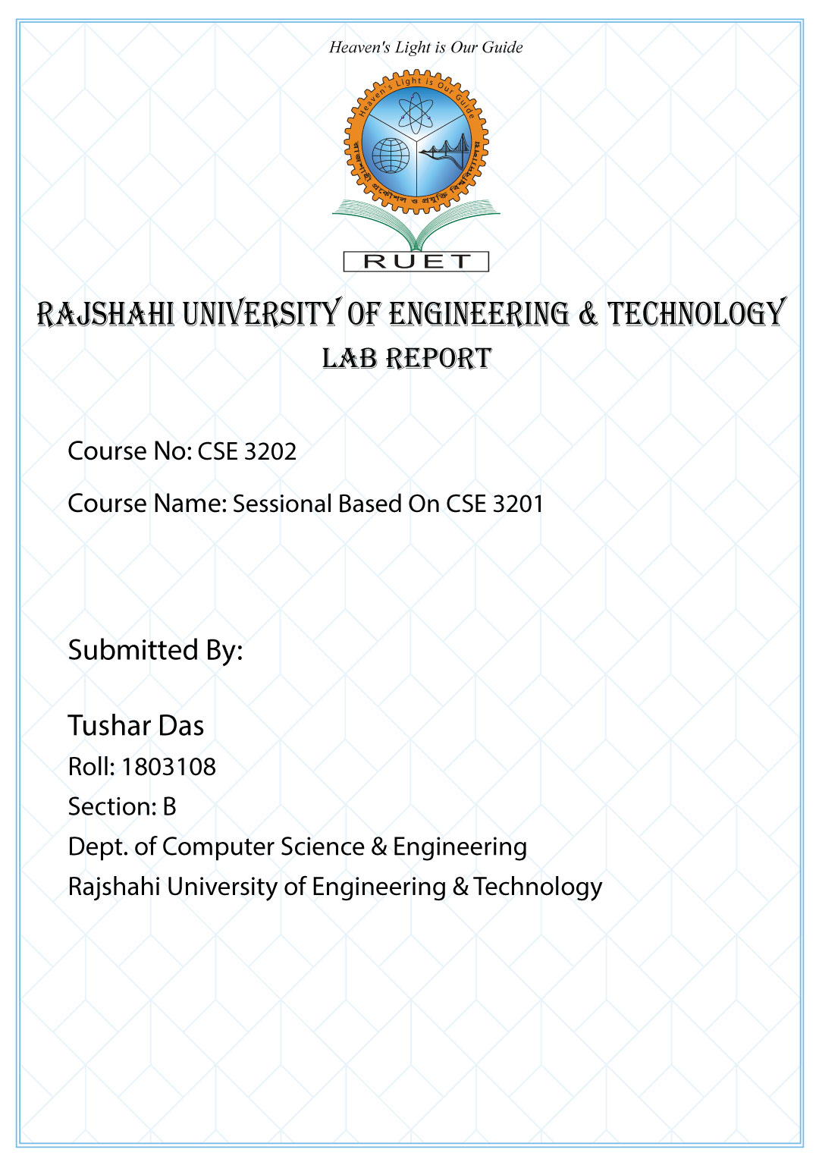**Lab 2**

**Shell Coding**

**First Shell Code**



#! /bin/bash

echo Hello World!

**Output**



**Variable**

The name of a variable can contain only letters (a to z or A to Z), numbers ( 0 to 9) or the underscore character ( _ ).By convention, Unix shell variables will have their names in UPPERCASE.

**Code**

#! /bin/bash

a=10

b=20

echo a=$a and b=$b

**Output**

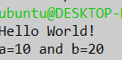

**Arithmatic Operation**

**Code**

c=$((a+b))

echo $c

**Output**

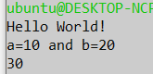

**Practice 1**

**Code**

d=$((c*c))

echo $d

**Output**

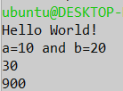

**Precision Of Number**

**Code**

e=10.11

f=10.11

g=$e+$f

echo $g|bc

echo "scale=5;11.2113/3"|bc

**Output**

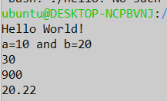

**Root of Number**

**Code**

echo "root of 13 is "

echo "scale=4;sqrt(13)"|bc

**Output**

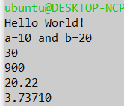

**Input From User**

**Code**

echo "Enter one number:"

read h

echo "Enter another number:"

read i

echo "Your selected number is $h & $i"

**Output**

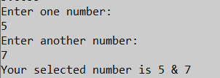

**If Else Condition**

**Code**

if [ $h -gt 0 ]

then

echo "You selected positive Number"

else

echo "Negative"

fi

**Output**



**Loop**

**Code (While Loop)**

#While Loop

echo "Printed By While Loop"

i=1

while (($i <= 10))

do

echo $i

((i++))

done

**Output**

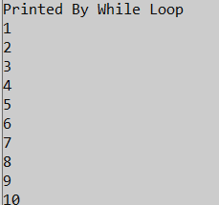

**Code (For Loop)**

#For Loop

echo "Printed By For Loop"

for i in {1..10}

do

echo $i

done

**Output**

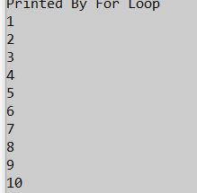

**Discussions**

This lab was for implementing basic shell scripting language. From this lab, we learned how to print, declare and store in variables, Arithmetic Operations, conditional statements, Loop statements in shell scripting language. This are the basic Programming concepts which is a must to learn a new language and in this lab we achieved this basic knowledge. All preliminary terms were learned from this lab.